Granite uses SSRS for reporting. This document will outline all the required setup steps for SSRS on a customer’s server.

**NB!!** If your customer is using the server as a Domain Controller, SSRS will NOT install. To get around this, try the following:

1. With customer’s permission, remove DC rule, install SSRS, and reapply DC rule
2. Customer to provide and alternative server / PC to run SSRS (must be within same network and be accessible from user’s PCs, i.e. can browse to the SSRS report url

# Installing SSRS 2019 Standalone:

Configuring SSRS

Base configuration

Adding GraniteWMS branding



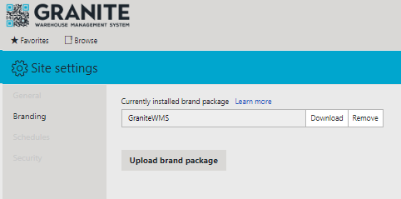

Upload latest ZIP file from “Dropbox\Software Installs\Granite\Granite Reports\SQL Server Reporting Services\Granite Branding\”

Adding report folders

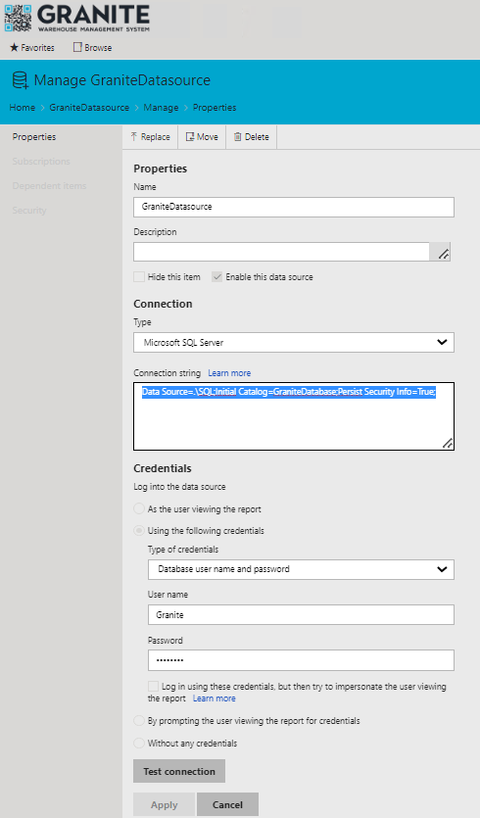Adding shared datasource (for all reports)

Name: GraniteDatasource

Connection String: Data Source=.\SQL;Initial Catalog=GraniteDatabase;Persist Security Info=True;

Type of Credentials: Database user name and password

User name: your Granite DB user

Password: your Granite DB password

Configuring SSRS site and folder security

Click apply

Change report datasource to shared databsource

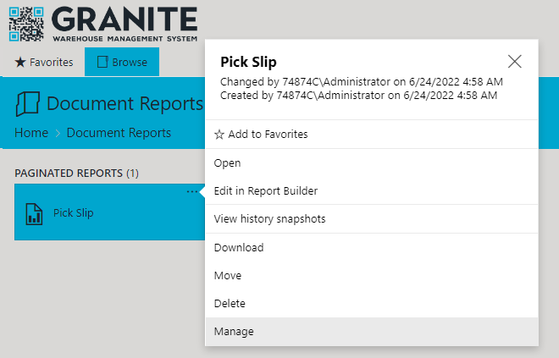

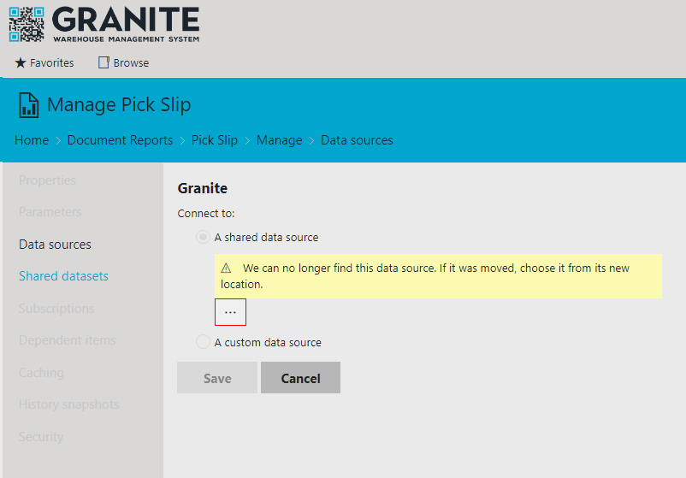

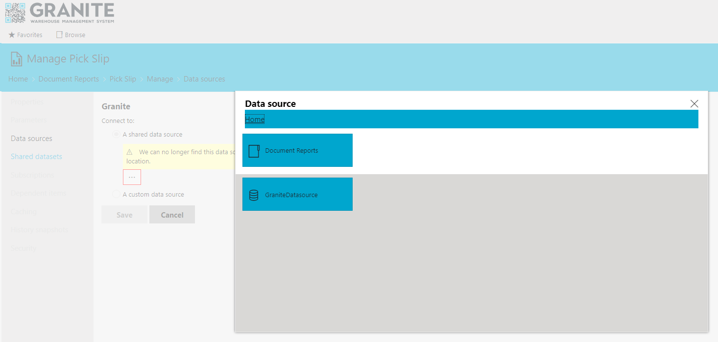

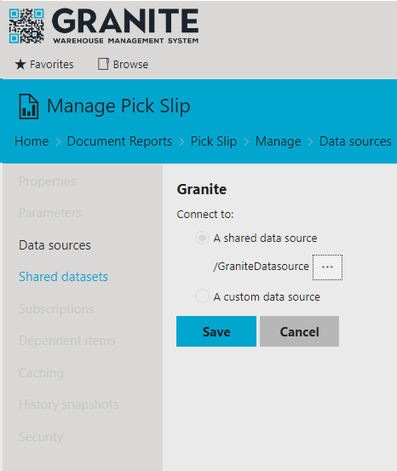

Click save

to setup SSR and execute automated report printing from a scanner process or desktop function.

Pre-requisites:

1. SSRS to be installed and configured
2. Report required to be uploaded and linked to shared datasource

apply barcodes to SQL Reporting Services reports.

Barcodes are rendered as images within SSRS, so to be able to produce a barcode on a report, the value to be printed must be passed through an image generator and displayed on the report as an image.

To set this up on the SSRS running server, the following needs to be in setup and configured:

**Copy file "BarcodeLib.dll" to the following locations on the SSRS server:**

1. For Standalone version of SSRS:

*C:\Program Files\Microsoft SQL Server Reporting Services\SSRS\ReportServer\bin*

1. For full SQL version installation:

*C:\Program Files\Microsoft SQL Server\MSRS10_50.MSSQLSERVER\Reporting Services\ReportServer\bin*

1. For development / report builder:

*C:\Program Files (x86)\Microsoft Report Builder*

*C:\Program Files (x86)\Microsoft SQL Server\Report Builder 3.0*

**Inside each report the following changes are to be made:**

1. Report properties  
   1. Select Report Properties (right click off the report page)  
        
      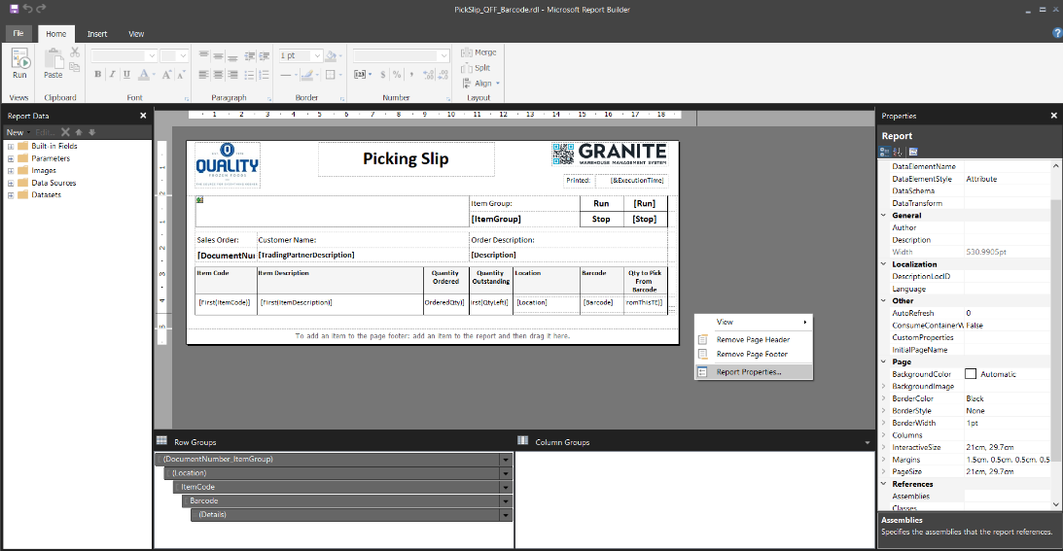
   2. The report properties require 2 changes:  
      1. Select menu option References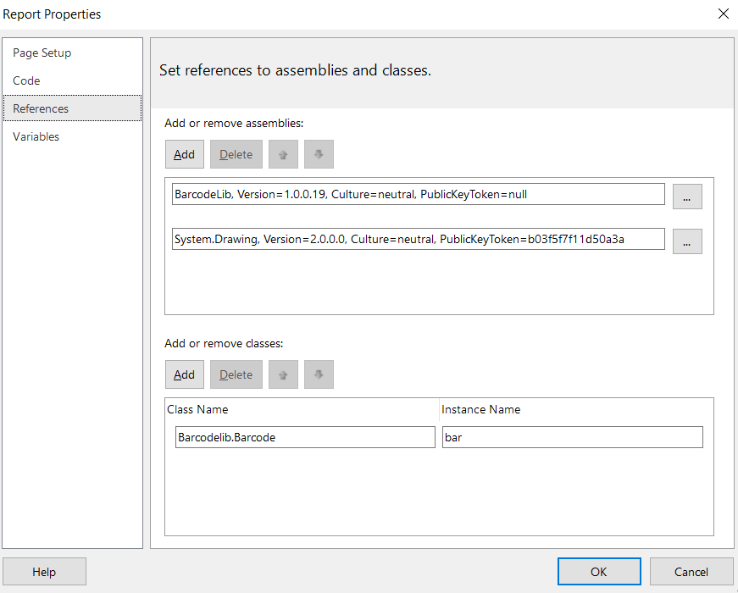  
         1. Add References to “BarcodeLib.dll” and “System.Drawing.dll” from the following:
      * BarcodeLib.dll (use server folder from above, i.e. standalone / full server)
      * System.Drawing.dll (C:\Windows\Microsoft.NET\Framework\v2.0.50727)  
        1. Add Classes
      * Class Name = Barcodelib.Barcode
      * Instance Name = bar
      1. Select menu option Code   
           
         This is localised report code which will pass through the value to barcodelib and generate an image   
           
         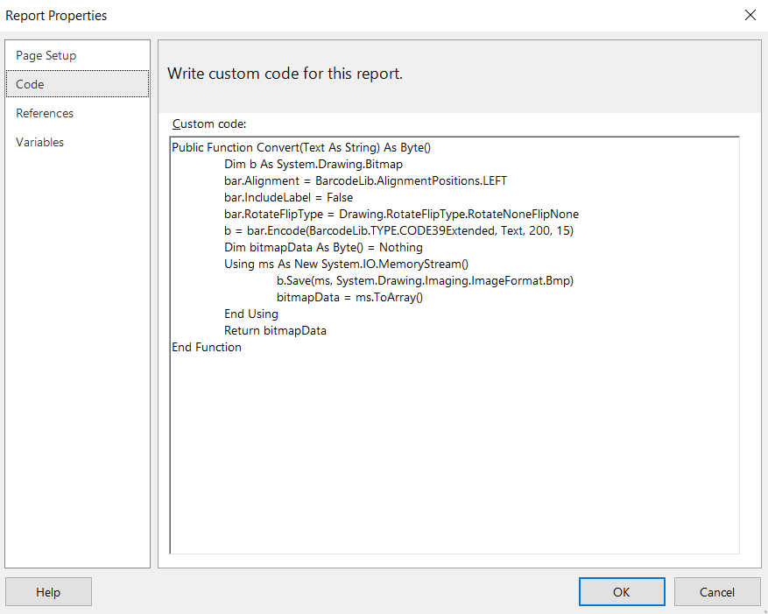  
           
         Insert the following code

*Public Function Convert(Text As String) As Byte()*

*Dim b As System.Drawing.Bitmap*

*bar.Alignment = BarcodeLib.AlignmentPositions.LEFT*

*bar.IncludeLabel = False*

*bar.RotateFlipType = Drawing.RotateFlipType.RotateNoneFlipNone*

*b = bar.Encode(BarcodeLib.TYPE.CODE39Extended, Text, 200, 15)*

*Dim bitmapData As Byte() = Nothing*

*Using ms As New System.IO.MemoryStream()*

*b.Save(ms, System.Drawing.Imaging.ImageFormat.Bmp)*

*bitmapData = ms.ToArray()*

*End Using*

*Return bitmapData*

*End Function*

1. Barcode in report  
   1. In report layout / design, insert an Image into the area for the barcode to be printed  
        
      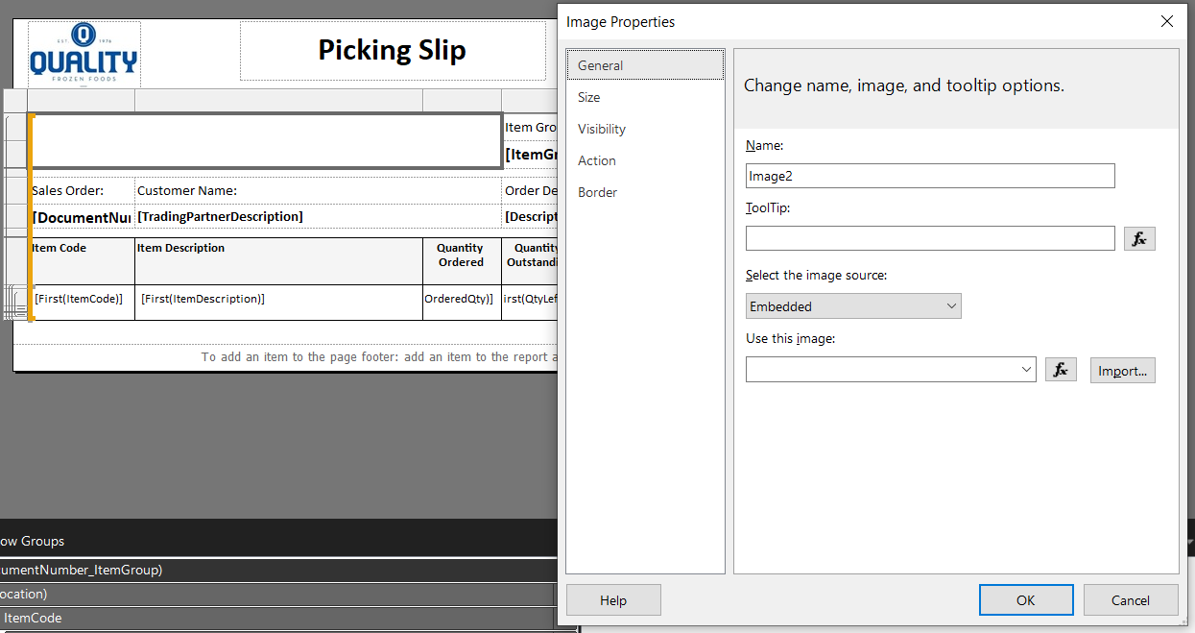  
        
      Settings to note for image added:  
      Image source Database  
      Expression =Code.Convert("*" & Fields!DocumentNumber.Value & "*")

MIME Type image/bmp  
Size Fit Proportional